Satellite image – enhancement of multispectral images – statistical evaluation
Content
Satellite image – enhancement of multispectral images – statistical evaluation 1
Content 1
Name: 1
Data: 1
1. Aim of the laboratory 1
2. Data 1
3. Statistical evaluation 1
4. Results 3
4.1 Landsat_Dobczyce_1997 3
4.2 EO1 ALI (9 kanałów)*: 3
5. Summary 4

Name:

Data:

- Aim of the laboratory
The main aim of the laboratory is to be familiar with the statistical image evaluation taking into account information content
- Data
- Landsat_Dobczyce_1997
- EO1 ALI
- Statistical evaluation
MOIK(KBxyz) = |rxy| + |rxz| + |ryz|
OIF(KBxyz) = (δx + δy + δz) / MOIK(KBxyz)

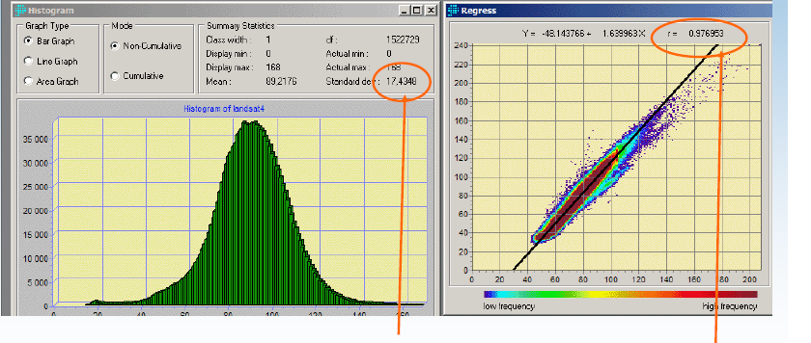

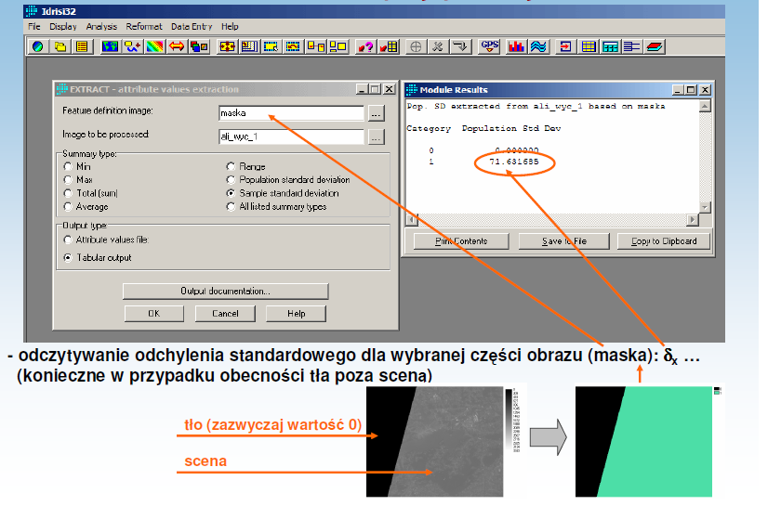

CC | MOIK | rank | OIK | rank | rank of visual interpretation
123
234
354
247
457

- Results

  - Landsat_Dobczyce_1997
Estimate the compositions: CC 123, 234, 354, 247 i 457
1. perform evaluation basing on the OIF i MOIK parameters
2. is consistency between both parameters?
3. do you obtain simillarity between formal and visual evaluation? If yes, more with MOIK or OIF?
4. select 3 best CC from statistical evaluation.

  - EO1 ALI (9 kanałów)*:
1. select the best CC, compare with the CC from Landsat
2. select 3 CC:
- only VIS;
- only IR;
- VNIR
3. test OIF i MOIK on ALI data: 14 bits i 8 bits (stretch with saturation. 1%)
*Notice:
Radiometric resolution of ALI: 14 bits. ALI channels correspond the Landsat.

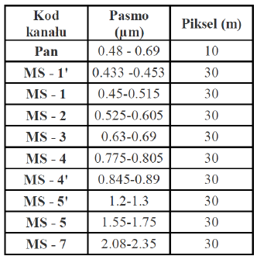

- Summary

